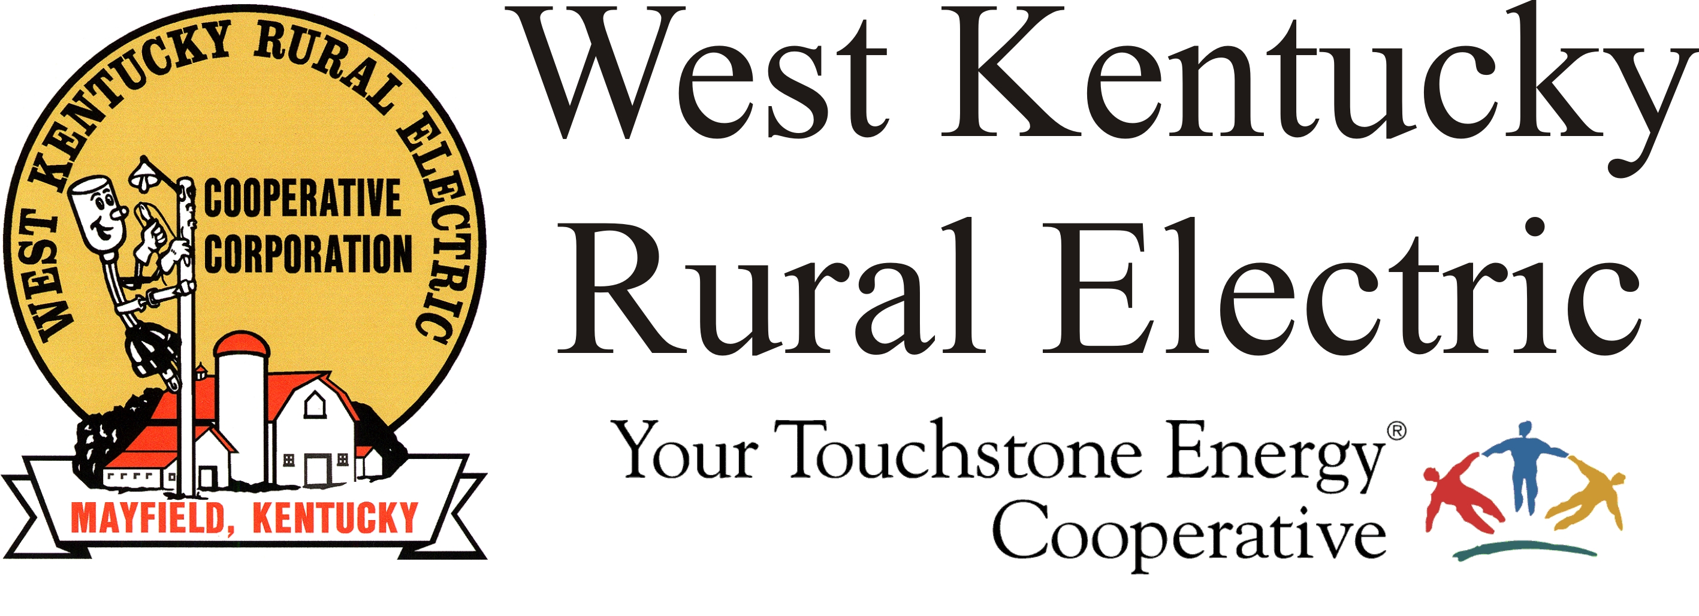

West Kentucky RECC Saturday Evening
Storm Damage Update

(Mayfield, Ky.) Dec. 11, 2021 (5:30 p.m.) – Today line crews have made repairs at dozens of locations across the service area. Our staking engineers have been out in the field evaluating damage and have created work packages to rebuild more than 10 miles of damaged lines and poles. We expect to replace more than 150 power poles through the restoration process.

Members should expect to be without power for several days. We ask for your patience as we rebuild after what is being called a “catastrophic” storm.

TVA reports that repairs are progressing with transmission lines serving West Kentucky Rural Electric Cooperative substations. Remember that these repairs are handled by TVA crews, so we don’t always have detailed information about where they are working and the progress they are making.

Our crews and contractors will continue working overnight on a staggered schedule that allows for linemen to take mandatory rest breaks after 16 hours of work. We expect to have more visiting crews here tomorrow.

About three-quarters of WKRECC’s 38,000 meters remain without power.

We continue to struggle with phone and internet availability due to regional outages. Our website and outage map are both inaccessible.

Please stay away from downed power lines and stay off the roads. Line crews and first responders are having trouble reaching their destinations due to heavy traffic.

Anyone with electricity-dependent medical devices or other health concerns should arrange to relocate or secure a generator. for an alternate power source. Please take steps to make sure your family is safe.

Our next update will be around 10 p.m.

We have limited staff resources to maintain this page, so please keep in mind we may not always be able to respond to your direct messages in a timely fashion. Thanks for your many encouraging messages.

Georgann Lookofsky
270-804-1701
glookofsky@wkrecc.com

